1. 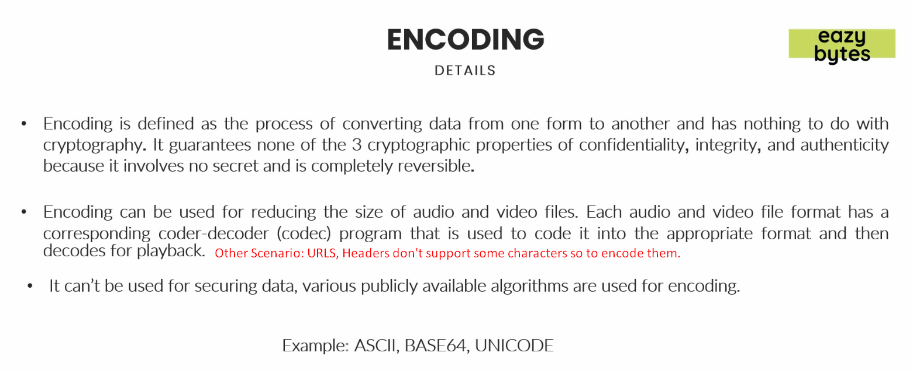

Encryption

1. Next Advanced version of encoding.
2. Even in encryption, the reverse is possible.
3. **Secrete Key**:
   1. Along with algo, a secrete key is used to encrypt the data.
   2. Then the convert the encrypted data form into the original form, the secrete key is required on the server.
   3. **NOTE**: Without secrete key, reverse process is almost impossible.
4. Better than Encoding as
   1. In encoding, if a person knows the encoded form of data along with the alog using which the original data was encoded, the reverse process can be done with any hard-word.  
      But in case of encryption it is not possible as we need 🡺 Encrypted Data + Algo + Secrete Key